The 2021 PTSA Reflections Program Has Arrived!

What is Reflections?

Reflections is a national PTA arts recognition program that helps students explore their own thoughts, feelings and ideas, and express them in an artistic form. Sandburg and DCS students have an opportunity for their artistic work to advance to the District, State, and National PTA levels for further review and consideration for awards.

What is the Reflections theme this year?
Who can participate?

All Pre-K to 5th Grade Sandburg and DCS students. We welcome students of ALL abilities. Entries are organized by grade levels:
  - Primary: PreK – Grade 2
  - Intermediate: Grades 3 – 5
  - Special Artist (for students with an ADA recognized disability): Pre-K – Grade 5

What are the Arts Categories?
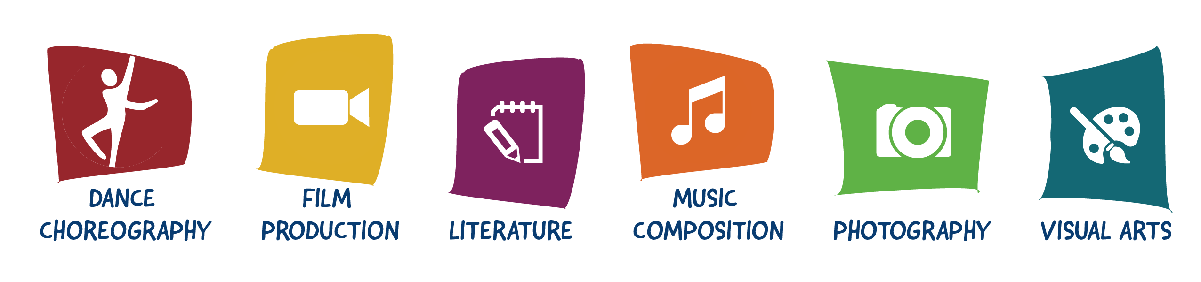
*Please note: Our PTSA can only accept 2D Visual Art. No 3D Visual Art permitted in that category.

Can a student submit more than one entry?

Only one entry is allowed per student in each art category. But a student can submit an entry in more than one category. All entries must be the original work of one individual student.

When are entries due ?

Wednesday, November 3rd, 2021.

How are entries submitted?

All entries are to be submitted online! The Sandburg and DCS PTSA Reflections Chair will provide assistance to any student needing help submitting their entry. See www.pta.org/reflections for more Program information and for inspiration from last year’s National PTA Reflections winners.

Need an official entry form, want more information, or have questions?

Please contact the Sandburg and DCS PTSA Reflections Chair, Janice Orr at janice.ptsa@gmail.com.

